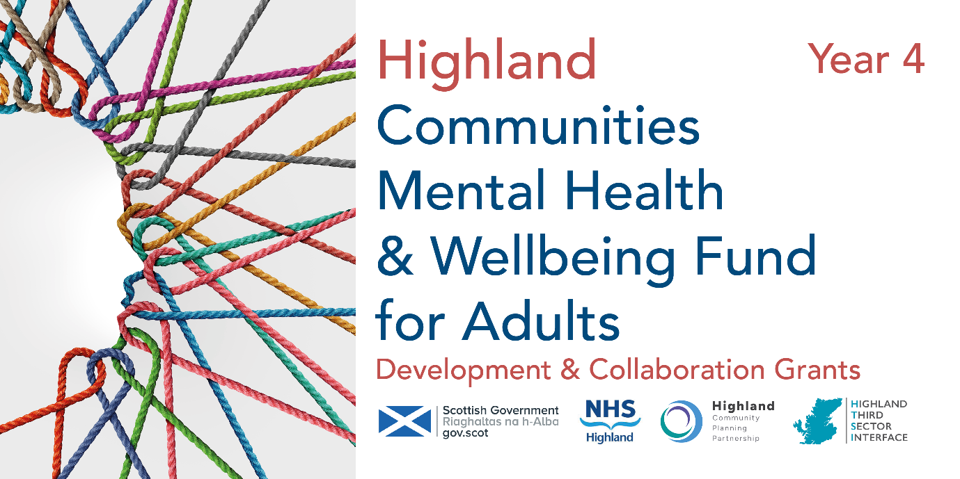
SAMPLE EXPRESSION OF INTEREST – PLEASE SUBMIT ONLINE
LARGE GRANT £50,000 OR LESS
We are applying for:
- Development Grant
- Collaborative Grant

Tell us about your organisation
- Name of organisation

- Main Contact
First Name:
Last Name:

- Job Title/designation

- Email Address

- Phone No

- Secondary Contact
Last Name:
First Name:
- Email

- Phone Number

- Briefly tell us about your organisation (50 words)
This is not where you describe your project plans

Tell us about your project
- Name of project and project postcode:

- Please tick one of the following types of initiatives which best describes your project

- Befriending
- Peer support
- Counselling
- Therapeutic
- Mentoring
- Financial inclusion/cost of living
- One to one
- Group activity
- Equipment
- Food
- Nature
- Social
- Arts and crafts
- Maintenance/repair
- Sport or physical activity
- Culture

- Please enter the number of volunteers involved in delivering the project

- Please describe the project including its key aims and activities and how this supports mental health and wellbeing. (max 100 words)

- Please tell us more about the community you’re working with and why you intend to implement the proposed development or collaborative project. (max 100 words)

- Please enter details for each partner you intend to collaborate with on this proposal:
 | Name | Description
1.
2.
3.
4.
- Is your project for the general population (general), open to all but with a focus on particular target groups (targeted) or aimed only at particular target groups (restricted)?
- General
- Targeted
- Restricted

- If your project is targeting specific groups of people, which groups of people are you seeking to reach? (Select no more than three)
- Women (particularly women affected by gender-based violence)
- People with a long-term health condition or disability
- People from a minority ethnic background
- Refugees and those with no recourse to public funds
- People facing socio-economic disadvantage
- People experiencing severe and multiple disadvantage
- People with diagnosed mental illness
- People affected by psychological trauma (including adverse childhood experiences)
- People who have experienced bereavement or loss
- People disadvantaged by geographical location (particularly remote and rural areas)
- People with neurological conditions or learning disabilities, and from neurodiverse communities
- Older people (aged 50 and above)
- Lesbian, Gay, Bisexual, Transgender and Intersex (LGBTI) communities
- Other (please describe)

- Cost of Living - the following family types are considered to be most at risk of poverty. Please select any (or all) who are highly likely to engage with this project.
- Lone parents
- Families with a disabled family member
- Families with 3+ Children
- Minority ethnic families
- Families where the youngest children are under 1 year old
- Mothers aged less than 25
- National/Local Priorities – please tick any (or all) of the following priorities your project will contribute to:
- Suicide prevention
- Social Isolation/loneliness
- Addressing poverty and inequality
- Other (select from Local Priorities List below)
- Unpaid carers and those with a long-term condition
- Rurally distanced
- Trauma

Tell us about your finances
- Please select the category which describes the income of your organisation:
- Organisation with income up to £5,000
- Organisation with income up to £10,000
- Organisation with income up to £25,000
- Organisation with income between £25,000 and £100,000
- Organisation with income between £100,000 and £500,000
- Organisation with income between £500,000 and £1 million per annum
- Organisation with income over £1 million per annum
- Have you received a grant from the Communities Mental Health & Wellbeing Fund from HTSI before? Yes/No
- Is your application for a new project or for a continuation/expansion of an existing project? (Select one)
- New project
- Existing project (funded through the Communities Fund)
- Existing project (New to Communities Fund but funded previously through another funding organisation)

[Applications to continue projects are only eligible for this fund if this is for development/improvement/expansion.]
Project Costs

- Total project costs (rounded to nearest whole number – no currency symbols or commas):
£
Combined revenue and capital costs

- Amount requested (rounded to nearest whole number - no currency symbols or commas)
£
Combined revenue and capital costs

Tell us more about your plans

- In which locality do you plan to focus your work?
- Badenoch & Strathspey
- Caithness
- Easter Ross
- Highland-wide
- Inverness-shire
- Lochaber
- Mid-Ross
- Nairnshire
- Skye & Lochalsh
- Sutherland
- Wester Ross

- Is there a specific geographic community or neighbourhood you will focus on within the above locality?

- Please select the dates you will start and finish your activity. We encourage you to begin as soon as possible after the final panel has concluded and funding agreements have been signed off. This would preferably be before the end of 2024 and by April 2025 at the latest. We expect most projects to conclude within 12 months or less.
Start Date
End Date

- Please confirm you have the authority for submitting this application and the potential undertaking it represents.
Signature
When you complete the online form, you can save your progress by clicking the save button at the end of the form. This will trigger an email to be sent to the email address you have entered in Q4 [main contact email] and will provide a link that allows you to continue your form.

