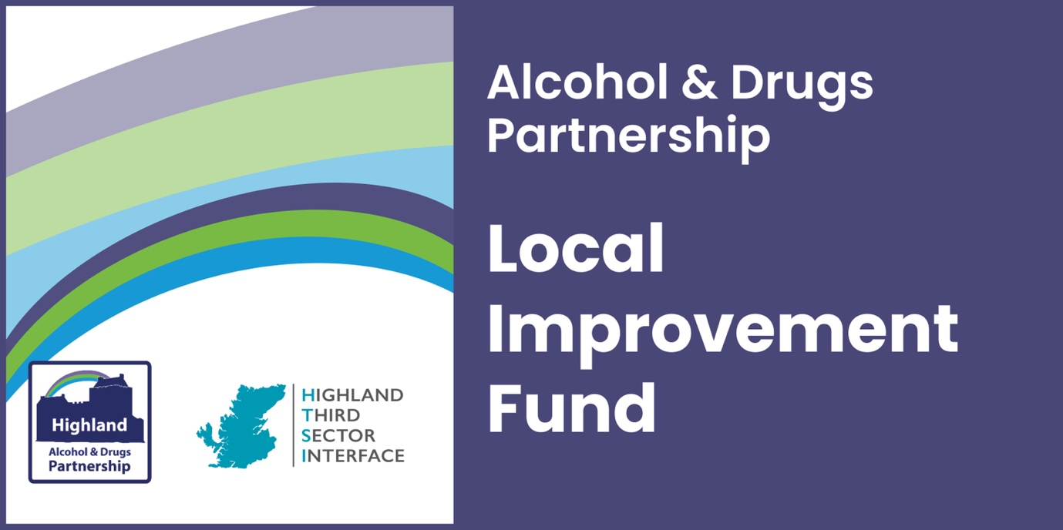

**APPLICATION**

**GUIDANCE**

Contents:

Purpose 2

Process 3

Questions 4

Submission 7

**Purpose**

**Highland Alcohol & Drugs Partnership vision:**

*Highland is an area where “we live long, healthy and active lives regardless of where we come from” and where individuals, families and communities:*

* *have the right to health and a life free from the harms of alcohol and drugs;*
* *are fully supported within communities to find their own type of recovery;*
* *are treated with dignity and respect.*

In January 2021, the First Minister announced a national mission to reduce drug related deaths and harms supported by an additional £50 million funding per year. The aim of the national mission is to save and improve lives through:

* fast and appropriate access to treatment and support through all services
* improved frontline drugs services (including third sector)
* services in place and working together to react immediately and maintain support for as long as needed
* increased capacity in and use of residential rehabilitation
* more joined-up approach across policies to address underlying issues.

Successful bids will focus on one or more of these strategic outcomes which complement the National Mission:

1. Fewer people develop problem drug and alcohol use
2. Risk is reduced for people who take harmful drugs and alcohol
3. People at most risk have access to treatment and recovery
4. People receive high quality treatment and recovery services
5. Quality of life is improved to address multiple disadvantages
6. Children, families and communities affected by substance use are supported

Process

You are invited to submit a funding proposal through the [Highland Third Sector Interface JotForm](https://form.jotform.com/221991630805356).

Applications must be completed by **Wednesday 27 November at 5.00pm** and will be assessed by a funding panel including Highland ADP members and people with lived experience. Funding will be provided within two weeks of successful applicants returning a signed funding agreement, as requested.

Assessment Criteria

Decisions will be based on how well your application demonstrates that you meet the following criteria:

* In line with the stated outcomes
* Previous experience operating in the Highland area
* Previous experience working with vulnerable people
* People-led proposals (lived experience shaping the project)
* Evidence of need identified through community engagement
* Clear outcomes for participants (which will be measured)

​

We would recommend applicants measure change in individuals’ wellbeing both pre and post intervention as a minimum, using tools such as the Warwick Edinburgh Mental Wellbeing Scale (WEMWBS) or similar. Details will be available to anyone wishing to use WEMWBS tools. We also recommend you carry out equality monitoring to demonstrate inclusion.

Before you complete the remaining questions, review your application against the criteria listed above. Are there potential areas for improvement to demonstrate your understanding of the key criteria?

Try not to make assumptions about prior knowledge on the part of panel members; include everything you think is relevant to your proposed activity.

Be clear, compelling and concise - making best use of the limited space provided.

This is the only application stage, so please leave enough time to check your answers with someone else. Once you submit your application, proposals that do not provide enough explanation or clarity may be rejected by the panel.

We recommend you save your application, as soon as you have entered your contact details, to confirm you can access the form to review your answers. If you encounter technical issues with JotForm, please email [enquiry@highlandtsi.org.uk](mailto:enquiry@highlandtsi.org.uk).

Questions

If a question is marked with a red asterisk, you are required to complete it.

**Bank account registered in the organisation's name:**

All groups applying must have a bank account and accounts from the previous financial year, which provides evidence of their ability to competently deliver their plans and account for the spend provided through a grant.

**Website -** please provide the URL of your preferred digital communication platform if you have one. If you do not have any online communication platform you may leave this blank.

**Select your organisation’s legal structure from the options:**

* Scottish Charitable Incorporated Organisations (SCIO)
* Unincorporated Associations
* Companies Limited by Guarantee
* Trusts
* Not-for-profit company, asset locked company, or Community Interest Company
* Cooperative and Community Benefit Societies
* Community councils

**Q1. Tell us about your organisation: you should include your experience operating in Highland and working with vulnerable people. (200 words)\***

Provide a brief statement about your organisation, which includes experience operating or delivering services in the Highland area. You should also include your organisation’s experience working with vulnerable people and how you safeguard staff, volunteers and participants.

**Q2. Provide details about your proposed project: you should include the type of activities; outputs, such as number of participants, sessions, staffing; and relevant timing. (250 words)**

Please use formatting to provide a clear, compelling description of your project, including the topics requested: activities, outputs and timing.

**Q3. What difference will this make and how will you measure this change? (100 words)**Describe the outcomes for participants and/or the community you aim to reach. Outcomes are changes you hope will happen because of the activity you deliver and should be measurable and realistic. How will you know when these changes happen and what methods will you use to capture relevant indicators?

**Q4. Select one or more outcomes from the National Mission below that your project will contribute to:**

1. Fewer people develop problem drug and alcohol use
2. Risk is reduced for people who take harmful drugs and/or alcohol
3. People at most risk have access to treatment and recovery
4. People receive high quality treatment and recovery services
5. Quality of life is improved to address multiple disadvantages
6. Children, families and communities affected by substance use are supported

**Q5. How did you identify a need for this activity/service? You should describe your engagement methods, and who you engaged with to identify this need.**

Strong local connections or with a thematic community will usually lead to more effective solutions for beneficiaries, minimise overlap and avoid duplication. This we want to know how you engaged and who with, to identify what this community needs. You should describe your involvement in relevant forums, networks, with related agencies and organisations. Be clear about the type of connection you describe, e.g. you may be an active partner in a network, alliance or coalition, working closely together, but other connections may be less active, i.e. attending meetings or as a member, and you may exchange referrals with others.

**6. How did you identify that this project would benefit your community? You should explain how lived experience has/will continue to influence your project.**

We are looking for meaningful involvement of the community (thematic or geographic) which you aim to support with your proposals. Their involvement will have a direct influence on the success of your project. Please provide examples that demonstrate how the community influenced your plans, particularly people with living or lived experience.

You may cite demographics, statistics or case studies which your proposals are based on, and you should draw comparisons that explain how you can be confident of the conclusions you have developed from this information.

1. **Start/end dates:**

Tell us when you plan to begin your project, using the date format DD-MM-YYYY and choose a date no earlier than 1 January 2025. Activity may not begin until payments reach successful applicants.

You may choose to deliver an activity for up to 12 months – we would like to leave some room for flexibility should projects encounter delays and need additional time to conclude the funded activity. All funded activity must conclude by March 2026 at the latest.

Financial Breakdown

Please provide a breakdown of the total project costs even if they would not be funded from the amount requested from this fund. You should not attempt to itemise each individual cost. Try to group items together in cost headings, such as staff/volunteer costs.

You only need to type in the white cells of the table, there is no need to edit the grey cells. Remove any currency symbols, punctuation, text from the figures and rounded up to whole numbers.

1. **Projected REVENUE expenditure for the project:**

Revenue costs are often associated with staffing costs or regular overheads like room hire, food supplies, tutor hire. This may include, but is not restricted to the following:

* Staff costs (including pensions and employers’ costs)
* Professional fees/Insurances
* Room hire
* Travel costs
* Volunteer expenses

1. **Projected CAPITAL expenditure for the project:**

Capital costs refer to the funds used to acquire, upgrade, and maintain physical assets such as buildings, technology, and equipment necessary for the project. These expenses are typically one-time costs that contribute to the long-term value and functionality of the project. Examples of capital expenditure include the purchase of land, construction of facilities, major renovations, and procurement of machinery or significant technology systems.

1. **Match funding (please enter details if applicable)**

If you have match funding, we ask that you kindly provide details of the amount, the origin and select yes or no to indicate whether t confirmed at the time of this application.

1. **Total project costs -** Confirm the total project costs, which should be the combined revenue and capital costs provided above.
2. **Amount requested –** Confirm the amount requested from this fund (maximum £10,000)
3. **Please provide income/expenditure details for the period ending 31 March 2024** for your whole organisation, not the department related to this application. Figures should be rounded up to the nearest whole number, with no currency symbols or text.

Please provide information for the financial year (12 months) ending in March 2024, if possible. Ordinarily, this would be the same period as your latest verified accounts cover, but it's not essential if this is not possible. If your organisation's accounts cover a different 12-month period, please complete the figures for that period, confirm the dates and explain.

This information is usually accessible through your organisations balance sheet, but you may need assistance accessing this. Please make sure you build in enough time to access this from the person who handles your finances, especially if this is external to the organisation. Failure to include this may result in your application not being assessed.

We have provided a free text box to provide any explanation required on your accounts. They may cover a different period of time, for a previous financial year or contain apparent anomalies you need to explain to the panel.

1. **In which locality do you plan to focus your work?**

* *Badenoch & Strathspey*
* *Caithness*
* *Easter Ross*
* *Highland-wide*
* *Inverness-shire*
* *Lochaber*
* *Mid-Ross*
* *Nairnshire*
* *Skye & Lochalsh*
* *Sutherland*
* *Wester Ross*

If you plan to work in more than one locality, please select Highland-wide.

**Upload accounts** – please attach a copy of your latest independently verified accounts

Submit

Submit the application by **Wednesday 27 November at 5.00pm** via the online portal.

[**https://form.jotform.com/242891715586368**](https://form.jotform.com/242891715586368)